Design Notes: Shadow of Protoman

Level:

* Recreation of Shadowman’s Level from Megaman 3
* Combining Junkman and Cloudman’s stages from Megaman7
* 3-5 Enemy Types on the Stage (As many as possible from M3)
* Level hazards: Pitfalls, Darkness
* Stretch out Shadowman’s level and overlay new assets

Protoman:

* Walk
* Jump (Once)
  + Controllable direction
* Shoot Buster (3 shots at one time)
* Charge Buster (hold buster to charge a super shot)
* Dash (Dashes forward)
  + Uses shield first, deflecting projectiles and pushing enemies
  + Shield has durability based on how many projectiles it has deflected (acts as using classic megaman power meters) – Will regen slowly overtime
* Dash in Air (Dashes forward in air)
  + Uses shield first, deflecting projectiles and pushing enemies
  + Shield has durability based on how many projectiles it has deflected (acts as using classic megaman power meters)- Will regen over time
* After defeating Shadowman, Protoman will receive “Shield Toss”
  + Protoman throws shield forward with a shadowy/wind effect that massively damages enemies.
  + Uses shield meter

Megaman:

* Walk
* Jump (Once)
  + Controllable direction
* Shoot Buster (3 shots)
* Slide
  + Changes Color based on Power

Shadowman:

* Jumps (multiple times)
* Sticks to wall
* Throws ninja stars (1-3 stars)

Drop Items

* Extra Health- Megaman health pick up
* Extra Lives- Dropped from specific enemies or hidden in level, Protoman’s head
* Energy for shield- Megaman energy pick ups

UI

* Health- Left Hand corner
* Lives- Protoman’s Head X Life Count – bottom right hand corner
* Shield Meter- Second special meter next to health that has a shield symbol/other telling symbol
* Pause Screen Text (Simple – Says “Pause” and freezes the game)

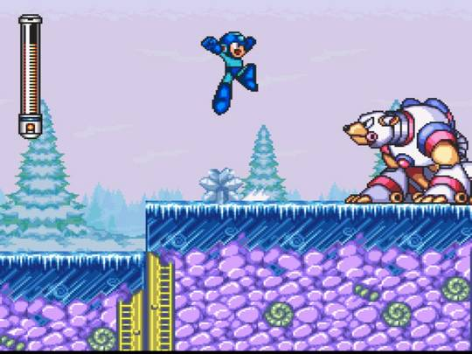

Title Screen

* 3D Model of Protoman playing the flute. Music in the background to sound like Protoman’s flute.